Derivation of Numerov’s Algorithm on a Non-Uniform Mesh
and Application to the Radial Schroedinger Equation

Matt Sieger
September 2007

Finite Difference Estimates of Derivatives

First derivative:

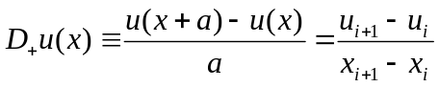 (1)

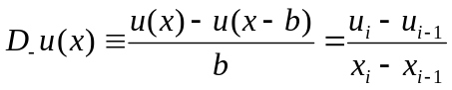 (2)

The centered approximation is the average of these two:

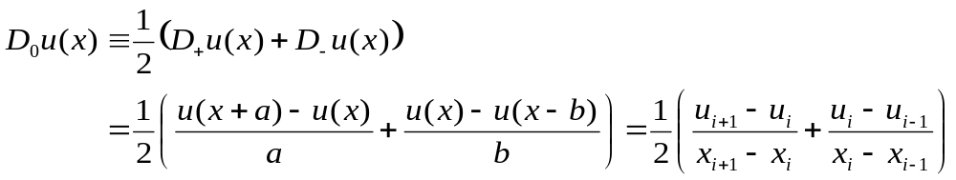 (3)

For a uniform mesh, the centered approximation reduces to:

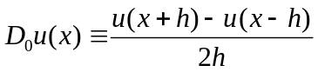 (4)

Expansions in a Taylor series about the point x,
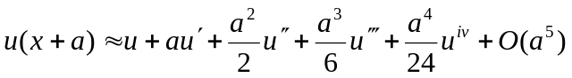 (5)
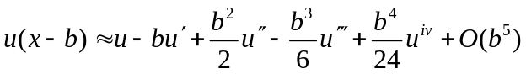 (6)
(7)

These can also be written in a discrete notation:

(8)
(9)

Estimate of error in finite difference approximation can be had by substituting into the expressions for Du the Taylor expansions of u(x ± h):

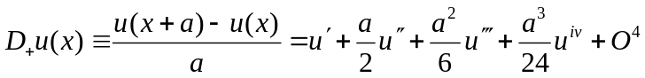 (10)
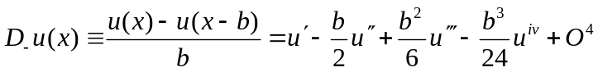 (11)

From these expressions, it can be seen that the expected deviation from the true value of the first derivative is dominated by the first term in a or b, meaning that the error is of first order in a (or b).

For the centered approximation, in the case of a uniform mesh, the alternating signs of the odd order terms in Eq 10 & 11 cause these terms to cancel out and the estimate is good to second order:

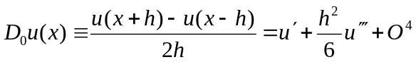 (12)

For the more general non-uniform mesh case, the cancellation of terms is not so clean:

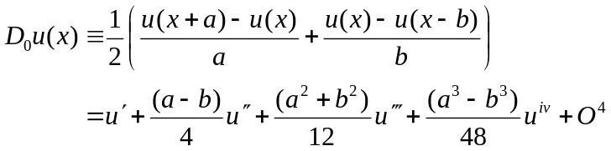 (13)

In this case, the error is dominated by a term of the order (a – b), or the difference in size of adjacent mesh points ( a – b = x_{i+1} – 2x_{i} + x_{i-1} ). If the gradient in the mesh is kept on the order of b² or better (i.e., x_{i+1} <= x_{i} + (x_{i} – x_{i-1})²), then this centered approximation is as good (or better) than that of the uniform mesh. This sets certain conditions on the mesh for the sake of accuracy.

Finite difference approximations of the 2nd derivative:

For a symmetric mesh, the centered approximation is

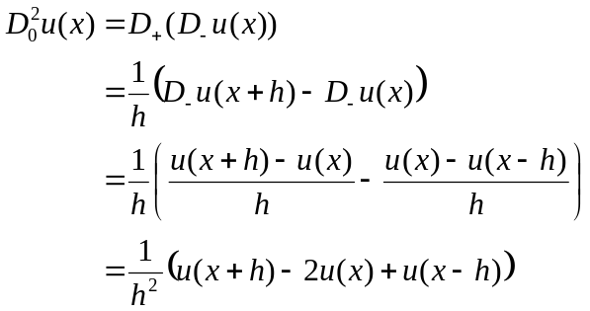 (14)

Substituting in the Taylor expansions, we arrive at the error estimate:

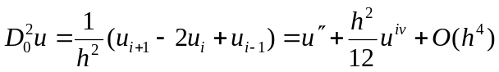 (15)

showing that the estimate in the 2nd derivative is good to second order.

Derivation of a 3rd order approximation:

For a non-uniform mesh,

One-sided approximations:
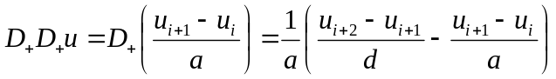

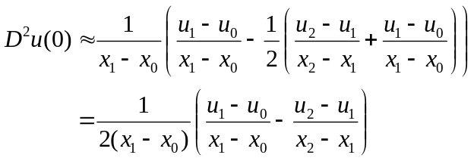
On a uniform mesh,

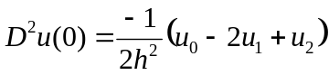

Somehow I don’t believe this. It is -1/2 times the 2nd derivative for point 1.

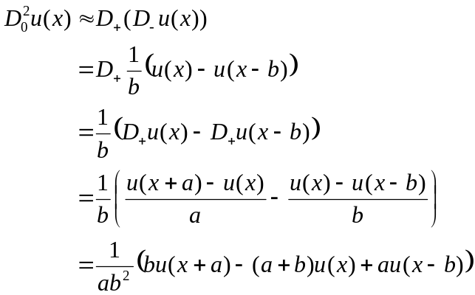 (16)

In the limit that a = b = h, this reduces to the form for the symmetric mesh.

Substituting in the Taylor expansions,

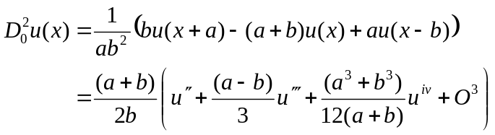 (17)

In the limit that a = b = h, this reduces to the correct form:

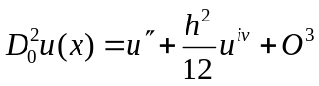

Note that the difference equation is not an estimate of the 2nd derivative, but of the 2nd derivative times an overall scaling factor. In order to make a “pure” estimate of the 2nd derivative, we need to scale the difference equation 16 with the overall multiplicative factor out front of eq. 17:

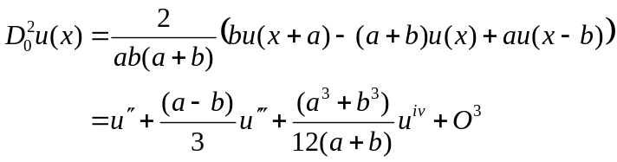 (18)

The dominant term of the error is 1st order in (a – b). In the uniform mesh limit, this reduces to

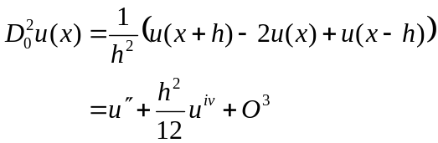

Which is the correct form for the uniform mesh. Note that calculating the non-uniform 2nd derivative difference as
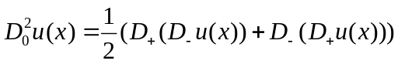
or
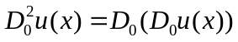
both give exactly the same result as Eq. 18.

Other combinations:

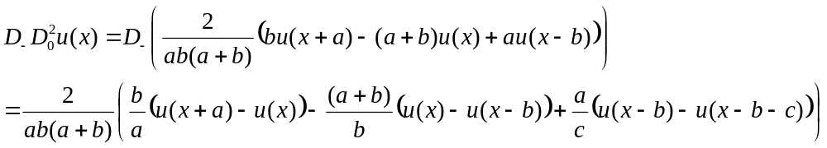

Here we’ve defined 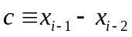

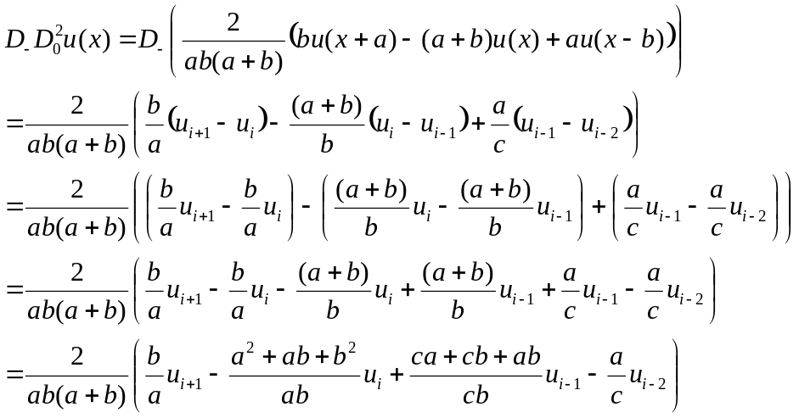

Estimating the error:
if a = b = c, then
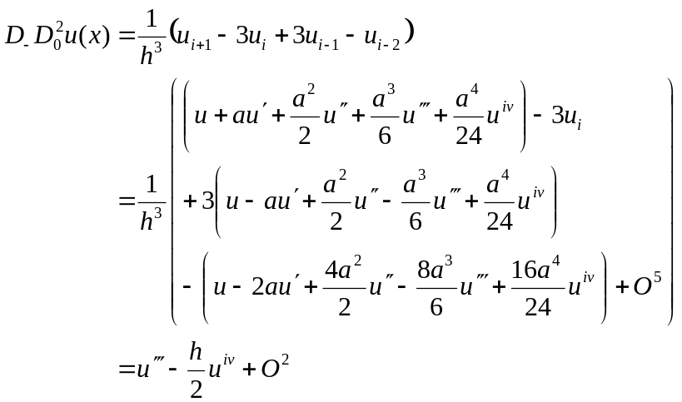

One-sided formula:

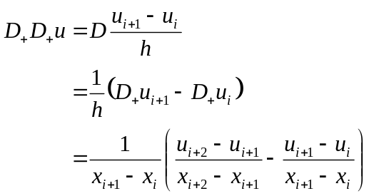
Define 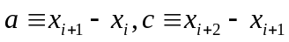
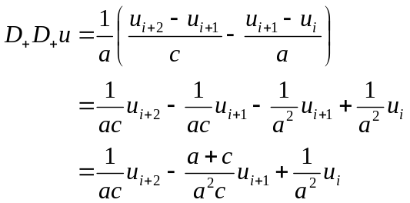

Estimating the error,

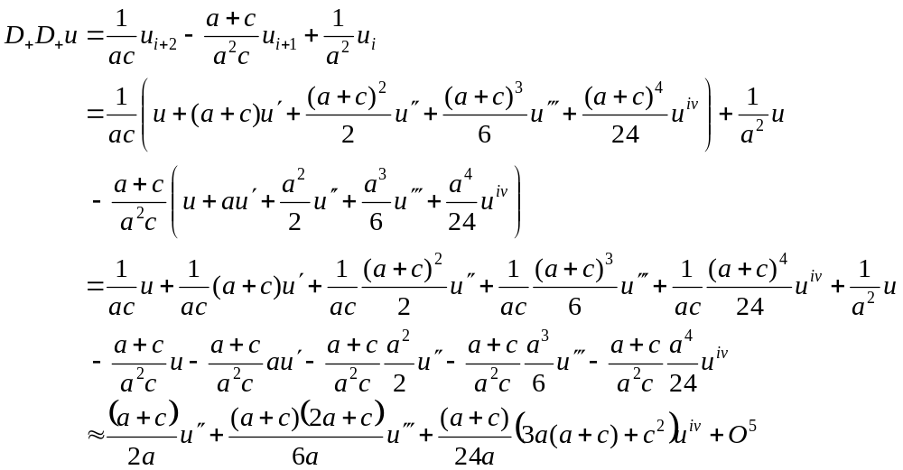

This is one of those cases where we need to normalize the RHS;
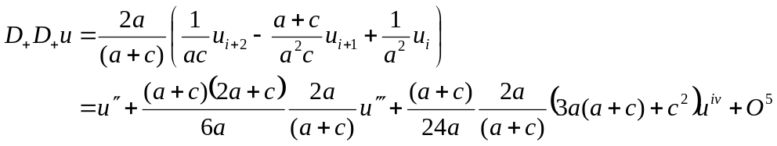
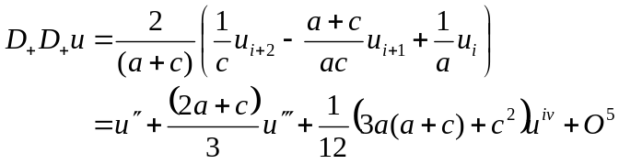

So this estimate is 1st order in the interpoint spacing.

In the case of a uniform mesh,
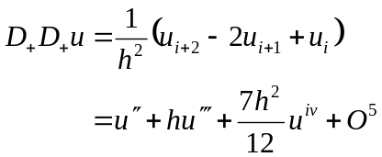

Coming from the other direction,
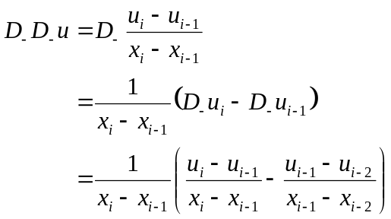
Define 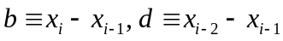
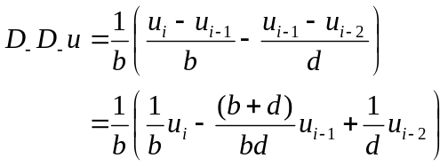

Estimating the error:
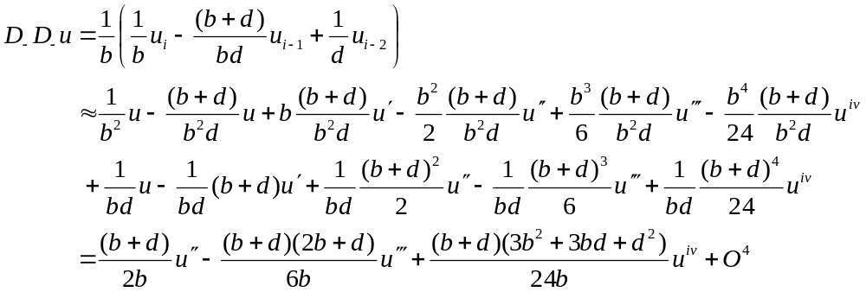

Again normalizing,
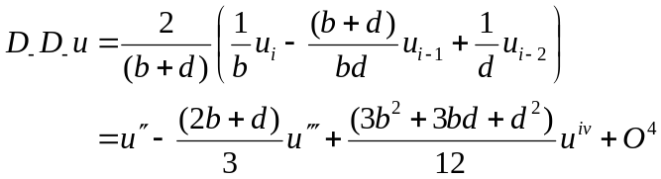

When b = d,

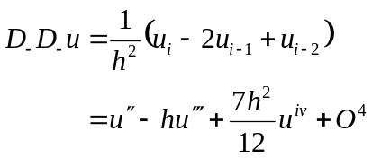

3rd order derivative on a symmetric mesh:

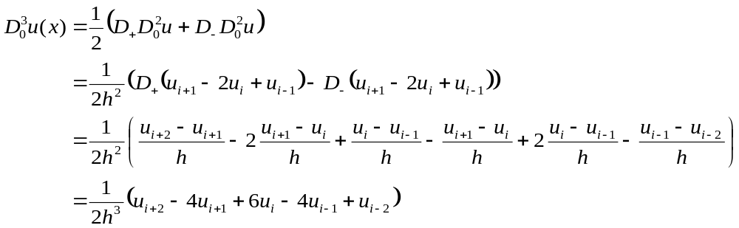

Subsituting in the Taylor expansions to arrive at an error estimate:

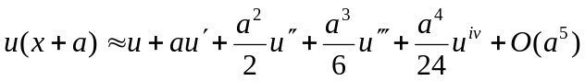

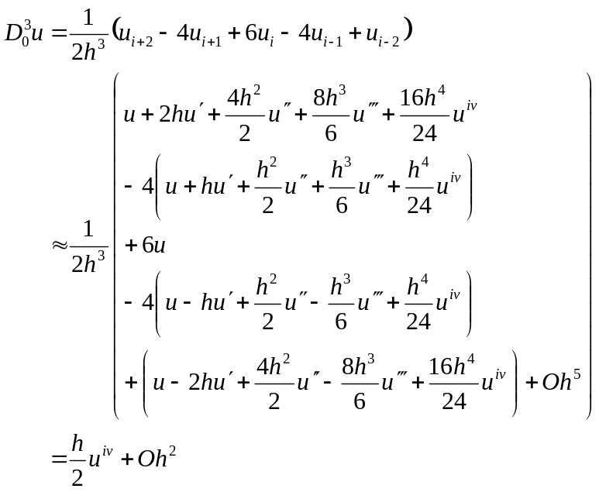

Interesting. This difference gives a good approximation to the 4th derivative.

From the text,

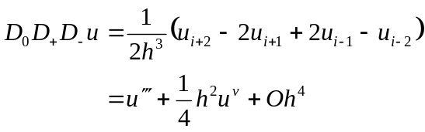

Polynomial methods:

For a general non-uniform mesh, it might be more practical to use polynomial interpolation methods.

If we take N adjacent points and fit them to a polynomial of order N-1, then the derivatives can be determined from the coefficients:

Summarizing FE Derivatives:

Taylor expansions:

First derivatives:

In general, we define

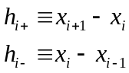

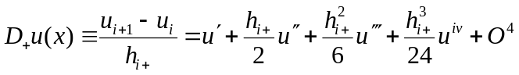
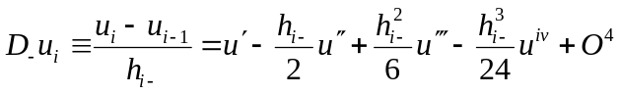

Uniform mesh:

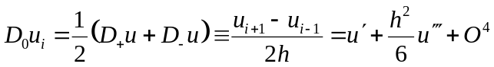
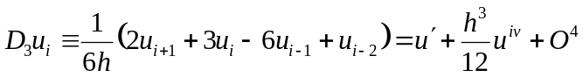

Non-uniform mesh:

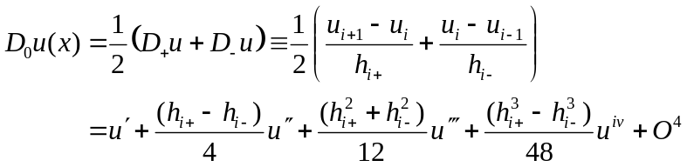

Second derivatives:

Uniform mesh:

Non-uniform mesh:
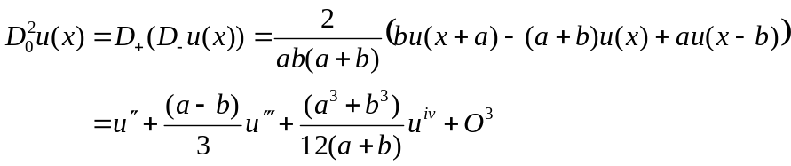

Higher derivatives:

Uniform mesh:

Non-uniform mesh:

Numerov’s Method on a Uniform Mesh

Numerov’s method is useful for solving DEs of the form:

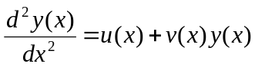 (19)

To obtain a finite difference scheme, we use the centered-difference equation (14) for the 2nd derivative:
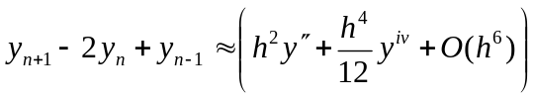 (20)

If we define 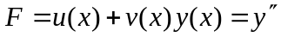, we get

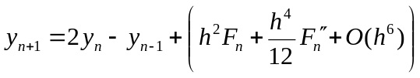 (21)

One strategy is to replace the second derivative of F with a centered difference,

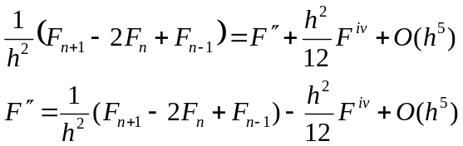
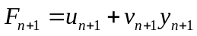

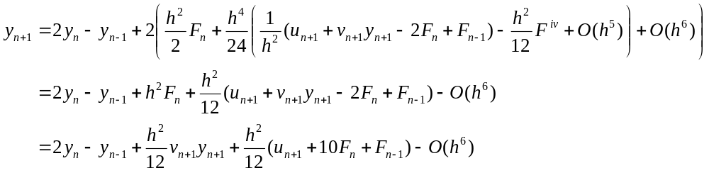
Note that the term including the fourth derivative of F is of order h⁶, and the O(h⁵) remainder becomes of order O(h⁹) upon multiplication by h⁴.

Collecting terms on y_{n+1}, we obtain the final result for Numerov’s method:

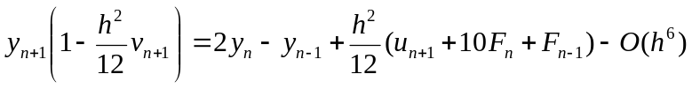 (22)

Multiplying through by the coefficient on y_{n+1}, we get

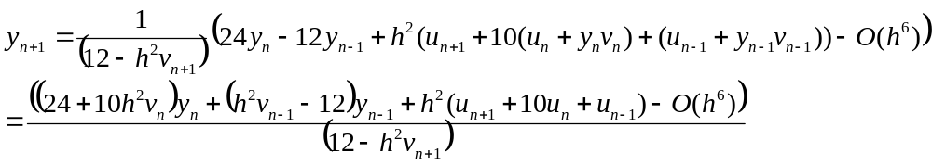

When u(x) = 0, this further reduces to

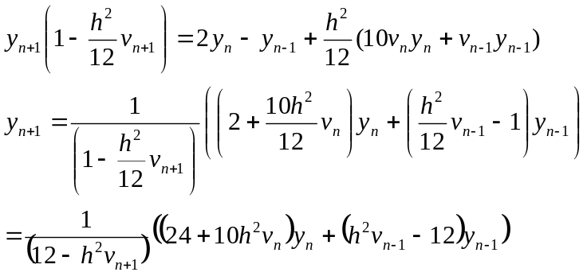

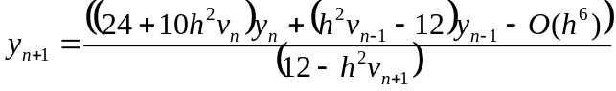

Numerov’s Method on a Nonuniform Mesh

We begin with the centered difference equation for 2nd derivative on a non-uniform mesh:

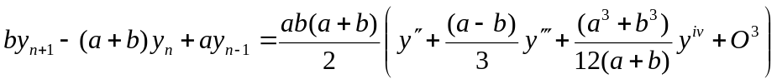 (23)

where 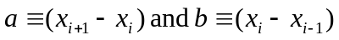.

As before, we define ,

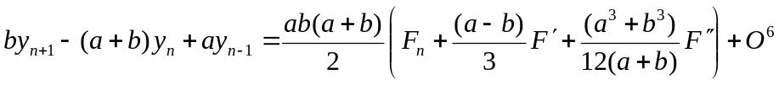

Replacing the first derivative of F with a centered difference,

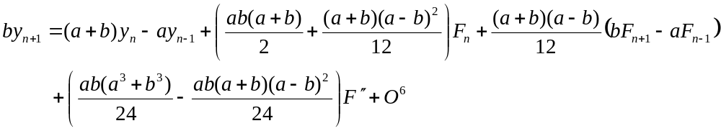

Now replace the second derivative of F by a centered finite difference:

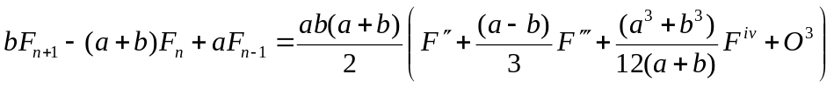,

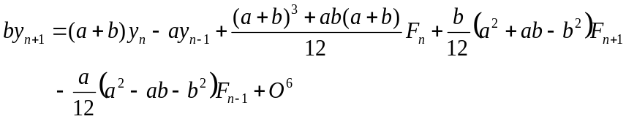

Since F_{n+1} is a function of y_{n+1}, we substitute:

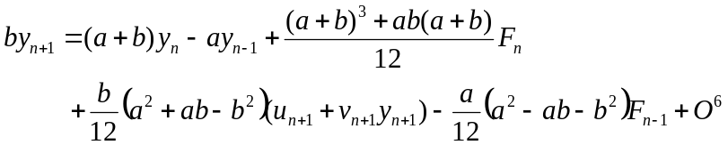

Collecting terms on y_{n+1}, we arrive at our result for Numerov’s method on a non-uniform mesh:

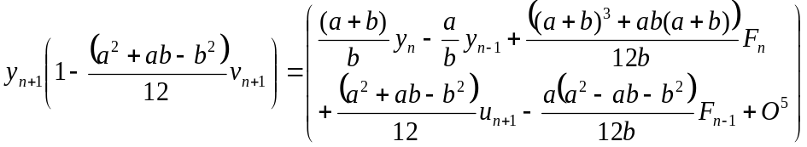

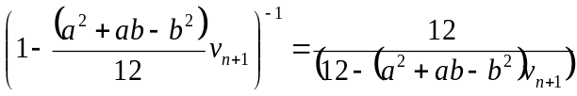

In the limit that a = b = h, this reduces to:

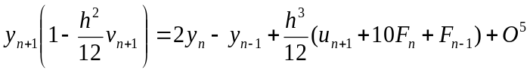

which is exactly equivalent to the uniform mesh result.

Special Cases

When u(x) = 0,

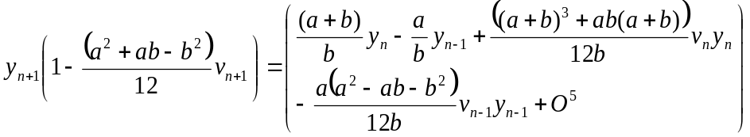

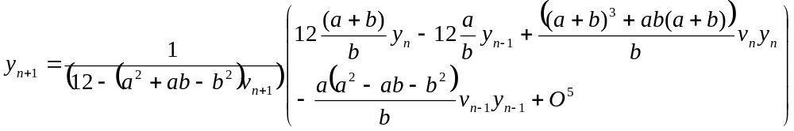

When u(x) = 0 and a = b = h,

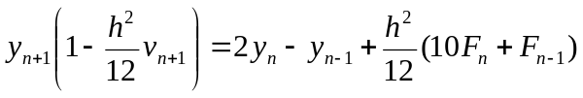
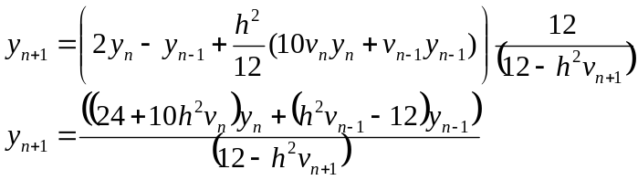

Calculating y₁

In order to apply this recursion relation, it is necessary to know the values of y₀ and y₁. If y₁ is not known a priori, it can be computed if the first derivative of y is known:

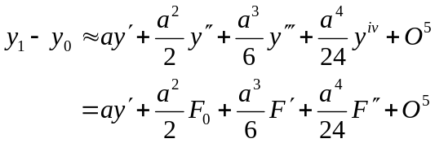
Similarly,
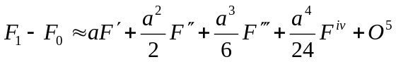
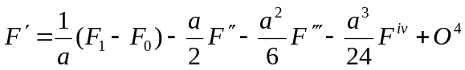

Substituting,

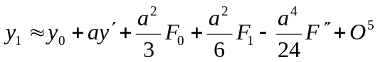

Substituting F₁ = u₁ + v₁y₁ and rearranging, the final result is (to O⁴):

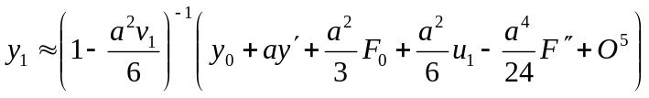,

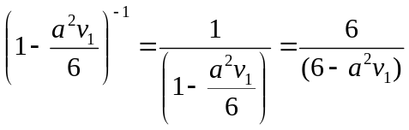
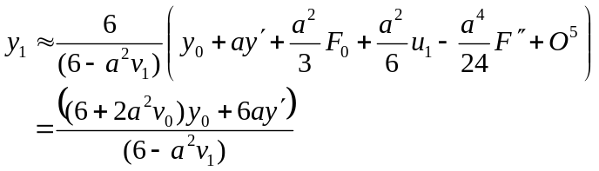

which matches Numerov’s result.

When y0 = 0,
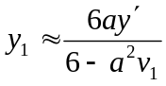

To derive the expression to O⁵, we need to compute the 2nd derivative of F:

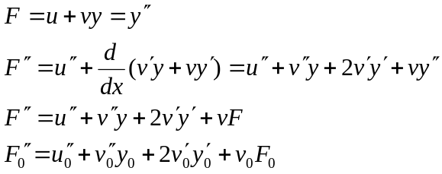

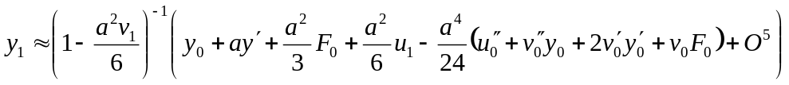

Now, in the case of our application (FE approximation to Schroedinger’s equation), u(r) = 0 and y₀ = 0, so this simplifies to

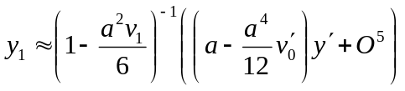

The 2nd derivative of F is multiplied by a⁴. To retain terms of overall O⁵, we need keep only the first few terms:

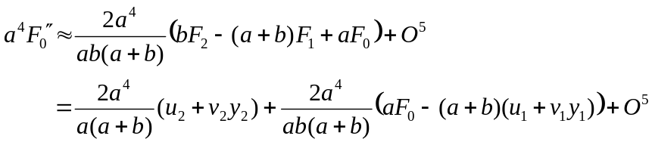

Now we need to delve into y₂. We need to know this value only to order a² to preserve O⁵:

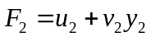

y₂ can be obtained from the full Numerov expression, which is:

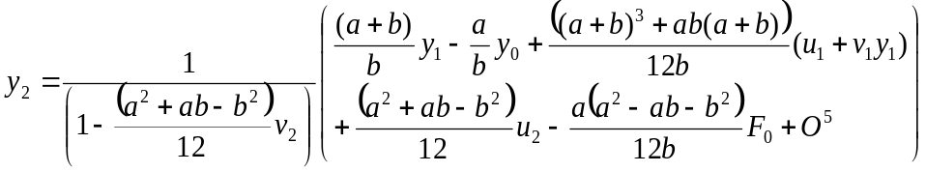

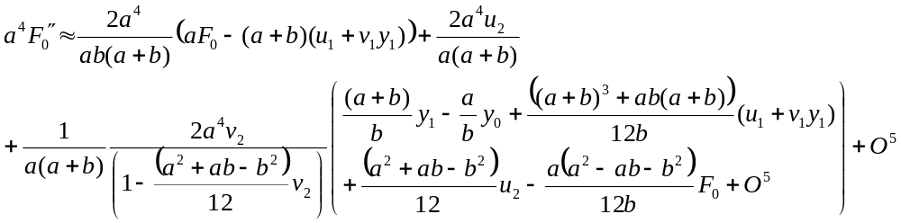

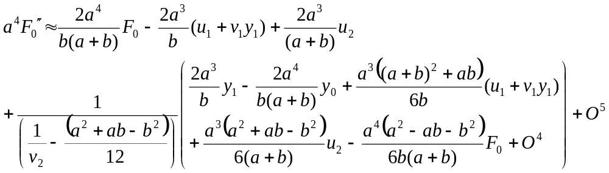

FE representation of the radial Schroedinger equation:

The radial equation that must be solved is:

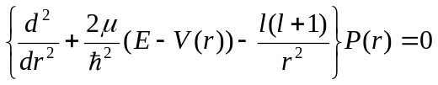 (19)
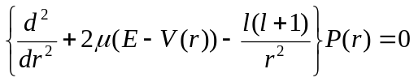(in Rydberg units)

where μ is the reduced mass of the electron and V(r) is the potential given above. I’m thinking this equation only has solutions for quantized values of E < 0.

The P_{i} are the r-multiplied radial wave functions:

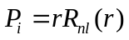 (20)

and are normalized such that

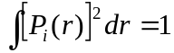 (21)

Cast in the form:

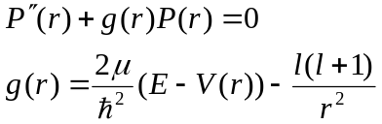

we can apply Numerov’s method with u(r) = 0, v(r) = g(r), and F_{n} = g_{n}P_{n} to solve numerically for P(r) on a generalized mesh:

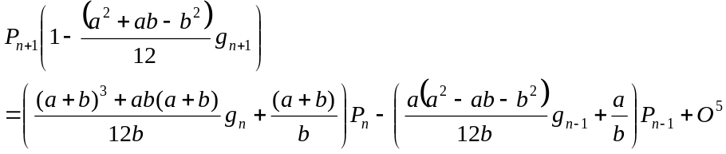

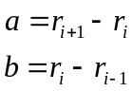

The boundary conditions require that

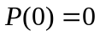

The form of the spherically symmetric radial potential is:
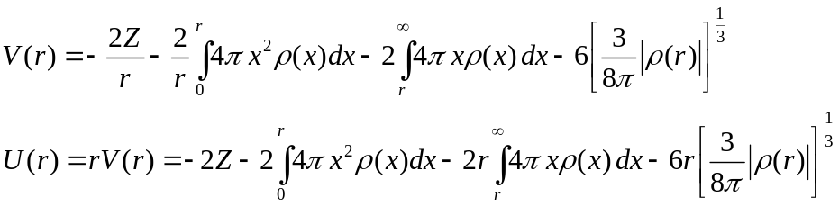

The r-multiplied potential U(r) has the advantage of being finite everywhere.

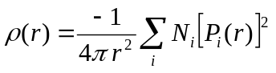

FE Solution to Radial Equation when E < V

Assume the solution is of the form:
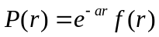
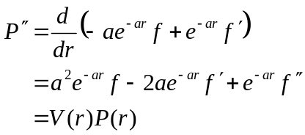

Substituting into the RSE produces an equation to solve for f (r):

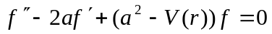

Discretizing on a uniform mesh,

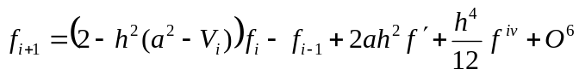

Using a similar finite difference for the first derivative produces

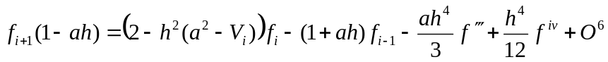

Further drilling into the third derivative,

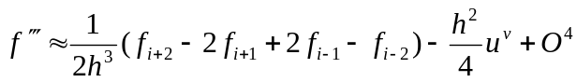

Substituting,

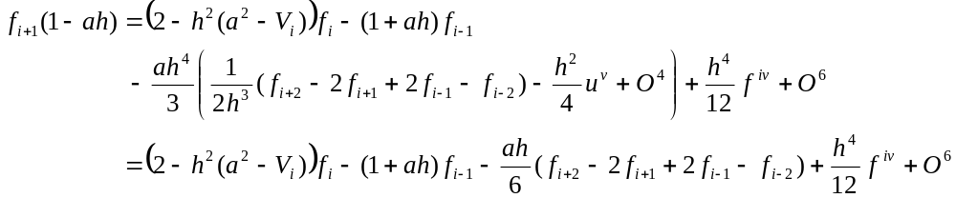
Note that terms in f_{i+2} have been introduced, so we reorient ourselves on this point:

Now we substitue for the 4th order derivative

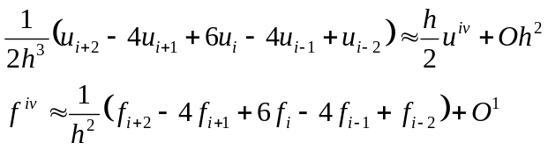

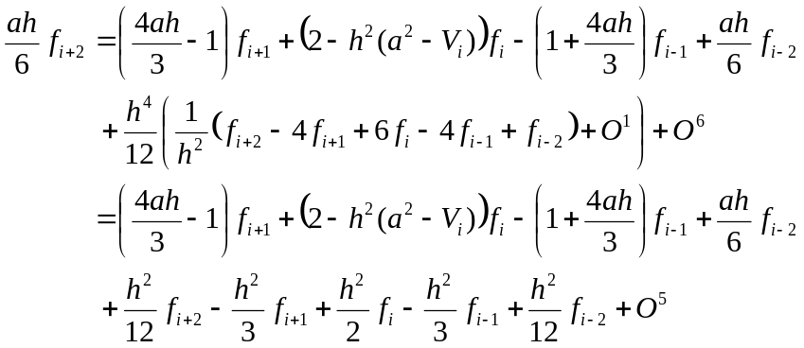

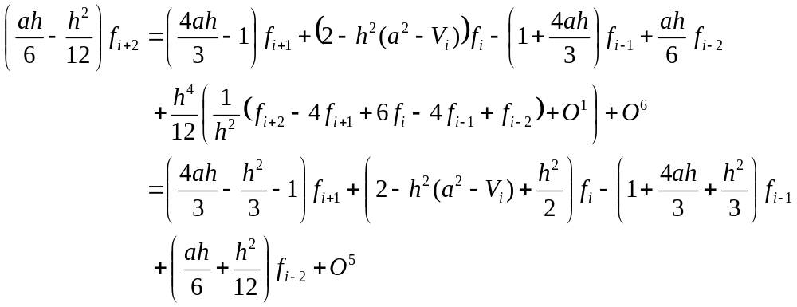

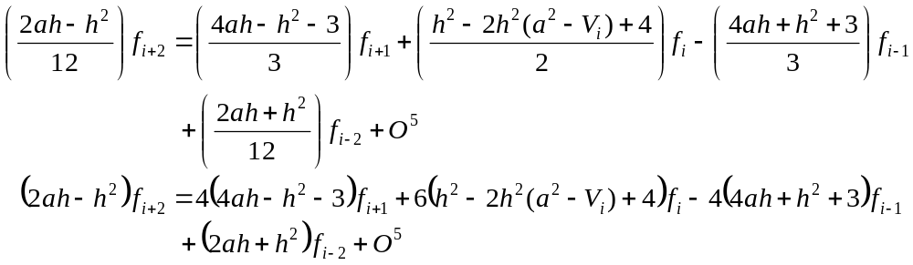

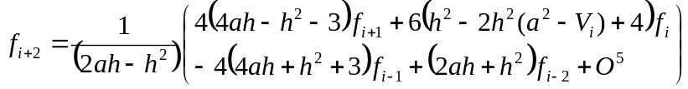

Since 